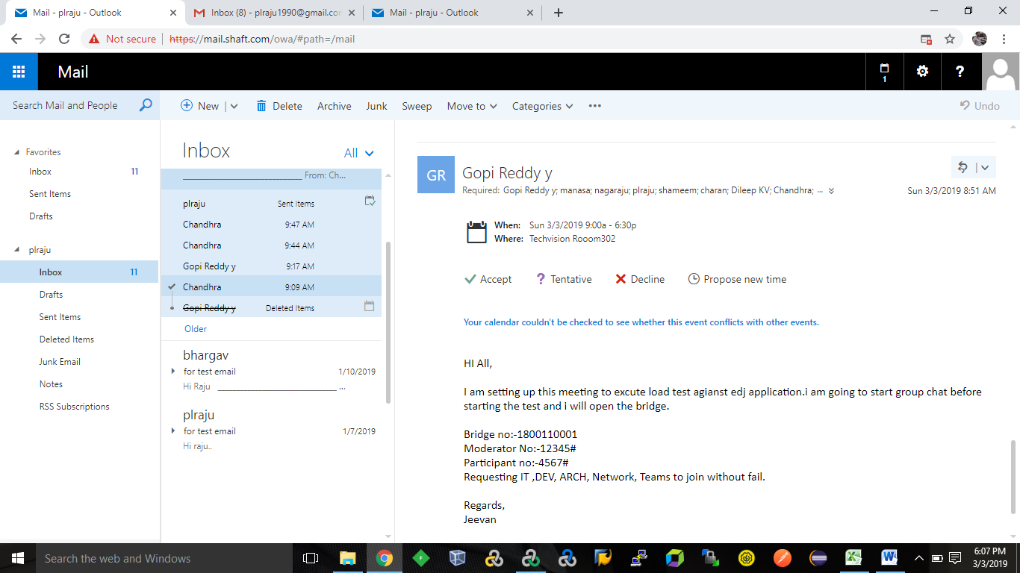

HI All,

I am setting up this meeting to excute load test agianst edj application.i am going to start group chat before starting the test and i will open the bridge.

Bridge no:-1800110001

Moderator No:-12345#

Participant no:-4567#

Requesting IT ,DEV, ARCH, Network, Teams to join without fail.

Regards,

P.L.Raju

**EDJ_Perfromance Testing**

1. Memory Foot Print Test:

HI All,

As part of Memory foot print test, Could you please send below details.

1.Web Server

2.App Server

3.DB Server

4.Load Generator

Regards,

P.L.Raju

---------------------------------------------------------------------------------------------------------------------

HI All,

As part of Memory foot print test, Could you please send below details.

1.Web Server:-10.10.10.51

2.App Server:-10.10.10.31/32

3.DB Server:-10.10.10.9

4.Load Generator:-

First LG: lr.shaft.com (4GB RAM And Dual core)

Second LG: 10.10.10.44 (4GB RAM And Dual core)

Third LG: LG+Controller (16GB RAM And Four cores)

Regards,

P.L.Raju.

Hi All,

Please find below for requested details as inline comments.

Reagrds,

P.L.Raju

Hi Team,

We Successfully Conducted Memory foot print test .

As part of Memory foot print test we identified

1.LG(10.10.10.44) can  accommodate 30 users

2.LG+Contoller(10.10.10.45)can accommodate  100 to 150 users

Regards,

P.L.Raju

-----------------------------------------------------------------------------------------------------------------

Hi Team,

We are planning to kick off Load Test Today. Could you please clean logs in server and bounce back up server.

Ticket No:-12345

Regards,

 P.L.Raju

---------------------------------------------------------------------------------------------------------------------

**2. DryRun Test.**

Hi Team,

As part of DryRun we found below issues and raise defects for same

   Defect No:-1     1111.While running the dry run 20 users App server reported  High Disk Utilization.

   Defect No:-2     2222.While running the test Web server Reported Running Out of Memory.

Regards,

P.L.Raju

---------------------------------------------------------------------------------------------------------------------

Hi All,

As part of dry run we found below issues and rise the defects for same

Defect no 1=1111

while running the dry run with 20 users,App server reported high disk utilization.

Defect no 2=2222

while running the dry run with 20 users,Web server reported running out off memory.

Regards

P.L.Raju

--------------------------------------------------------------------------------------------------------------------- Hi Team,

We allocated more memory for web server and cleared disk memory for app.

Defect: 1111,2222 (closed)

Regards

P.L.Raju

-------------------------------------------------------------------------------------------------------------------------------

HI Team,

Log files were deleted and bounce back the application. Please let me know if you need any help

Ticket: 12345 - closed

Regards

P.L.Raju

---------------------------------------------------------------------------------------------------------------------

**3. Load Test**

Hi All,

We are about to start load test with 100%  load .

Regards

P.L.Raju

Hi All ,

We are going to kick of the load test with 100% load.

Regards

P.L.Raju

-------------------------------------------------------------------------------------------------------------------------------

4. Failover Test.

Hi All,

We are about to start failover test.

Regards,

P.L.Raju

-------------------------------------------------------------------------------------------------------------------------------

**5. Rendezvous Test.**

Hi All,

We are going to start Rendezvous Test.

Regards,

P.L.Raju

-------------------------------------------------------------------------------------------------------------------------------